Tobacco Dependence Treatment Program for Health Care Providers
  - Panhandle Public Health District
Revised July 2018
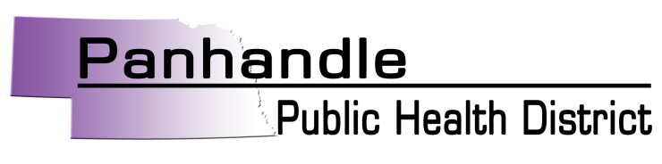
Proudly serving the Nebraska Panhandle Counties
Banner | Box Butte | Cheyenne | Dawes | Deuel | Garden
Grant | Kimball | Morrill | Scottsbluff | Sheridan | Sioux

Tobacco Dependence Treatment Program
POLICY:

PPHD will offer a systematic approach and support to partner clinics/hospitals offering a Tobacco Dependence Treatment Program in the Panhandle.

PURPOSE:

To provide a Tobacco Dependence Treatment Program, using evidence-based strategies, with success and fidelity across the Panhandle to reduce the number of tobacco users.

PROCESS:

This will be accomplished by following the regional systematic approach to offering a Tobacco Dependence Treatment Program.

Tobacco Dependence Treatment Program
For Adults ≥ 18 years old, who use any tobacco product

Tobacco User in ER
- Patient receives a patch at or prior to the four-hour mark

Tobacco User Admitted
- Patient receives a patch within the four-hour mark

Tobacco User Referred for Treatment
- Patient Review*
- Review their file – what are their options for pharmacological treatments.
  - Nicotine Replacement Therapy – no interaction with medications
    - Patch
    - Gum
    - Lozenge
  - Bupropion
    - Zyban/Wellbutrin
  - Varenicline - no interaction with medications
    - Chantix
* If pregnant – No pharmacological treatment for 2 weeks. If she doesn’t stop within 2 weeks try low dose patch or lozenge.

- Best Options in order
  - Varenicline/Chantix *
  - Patch and Gum
  - One standalone pharmacological treatment
*if more is needed add Bupropian

- Initial meeting with patient over the phone or in person
- Compete Self-Report Tobacco Assessment
- Determine which pharmacological treatment they want to use
  - Give them their options - be very specific. Would you like to use A, B, or C for your treatment?
- Write the prescription, determine they have they have the means to fill it.

- Follow up meeting over the phone
- Confirm they have filled the prescription
- Refer to Quitline 1-800-Quit-Now

- Maintenance calls biweekly over the phone
- Confirm they have begun using/are still using treatment and quitline.
- Use Motivational Interviewing.
- Discuss what there are feeling – withdrawal. Smoking reduce caffeine intake – you don’t need as much caffeine.

- Bidirectional Referral
- Send enrollment letter to referring physician after first maintenance call that the patient has used treatment and quitline.

Treatment Best Practices
- Maintain Treatment pharmaceutical and counseling for 6 months.
- Smoking while taking pharmaceutical treatments is not a concern.
- Use treatments to reduce usage if they are not ready to quit.

Quarterly Reporting / Tracking
- # of referrals
- # receiving pharmacological treatment
  - Which treatment
- # using quitline for counseling piece

Produced by
Tabi Prochazka  Health Promotions Coordinator  Panhandle Public Health District  tprochazka@pphd.org  (308) 487-3600, ext. 107 | Kelsey Irvine, MPH, CPH  Community Health Planner  Panhandle Public Health District  kirvine@pphd.org  (308) 633-2866 | With guidance from:  Treating Tobacco Dependence in Behavioral Health Settings Training, 2017

